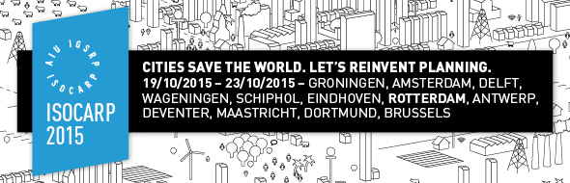

REGISTRATION FORM - POST CONGRESS TOURS 24-27 OCTOBER 2015

First name(s)
Surname(s)
Nationality
Gender
Date of birth
Address
Zip code
City
Country
E-mail address
Telephone
Cell phone
Post Congress Tour 1 (please tick) ☐ | Post Congress Tour 2 (please tick) ☐
Customised Post Congress Tour:
Remarks 1 (diet, special wishes, etc.):
Remarks 2 (single or double room) | Single room (standard) ☐ Double room ☐
Remarks 3 (if double room, shared with:)

One-day only Post Congress Tour (no hotel) @ € 200,- (please tick) ☐
One-day and one-night Post Congress Tour @ € 300,- (please tick) ☐
Two-day and one-night Post Congress Tour @ € 400,- (please tick) ☐
Two-day and two-night Post Congress Tour @ € 500,- (please tick) ☐
Three-day and two-night Post Congress Tour @ € 600,- (please tick) ☐
Three-day and three-night Post Congress Tour @ € 700,- (please tick) ☐
Four-day and three-night Post Congress Tour @ € 800,- (please tick) ☐

Please fill in and return this registration form for each participant to
Connecting Cities c/o Martin Dubbeling: martindubbeling@gmail.com

