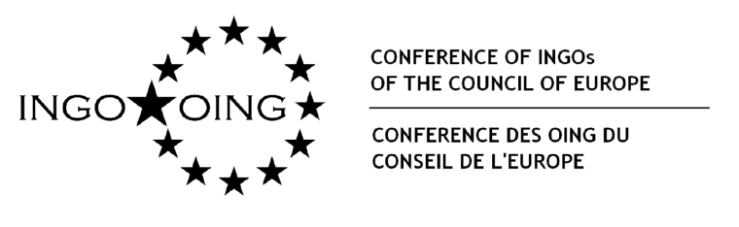

“Only a matter for politicians?
Civil society, money and political activities”
6-7 June 2016, Room 5, Palais de l’Europe, Strasbourg
The measure of a country’s democracy lies above all in the dynamism and diversity of its NGOs, whose closeness to the citizens enables them to initiate communication between the various segments of society and political institutions. In this context, they oversee respect for, and the effectiveness of, individual rights and the interests of vulnerable groups. Their activities among the general public drive innovation; they watch over the separation of powers in democratic states and are the principal whistle-blowers. Their political advocacy work provides assistance for policy makers.
Freedoms enshrined in law
Freedom of association is not limited to the creation and registration of NGOs but encompasses their freedom to function and carry out their activities. “No restrictions shall be placed on the exercise of (freedom of association) other than such as are prescribed by law and are necessary in a democratic society in the interests of national security or public safety, for the prevention of disorder or crime, for the protection of health or morals or for the protection of the rights and freedoms of others.” (Article 11.2 of the European Convention on Human Rights)
Freedom of association is being undermined, indeed compromised, today and necessitates a substantive discussion on strengthening the ability of NGOs, as democratic players in their own right, to take action.
Political activities of NGOs
In a democracy, NGOs contribute to the political debate and to the development of new operational and policy provisions. “NGOs should be free to undertake ... advocacy on issues of public debate, regardless of whether the position taken is in accord with government policy or requires a change in the law.” (Recommendation CM/Rec(2007)14 on the legal status of NGOs, paragraph 12)
The activities of NGOs in a democracy require a meaningful degree of independence and the possibility of taking action in the field of public policies. Do these activities lead to the assumption of power by NGOs? Are they a threat to public order?

The Expert Council on NGO Law recommends distinguishing between two dimensions of political engagement of NGOs: “political activities” in terms of the direct engagement of NGOs in the political arena, such as the nomination of candidates, financial support for political parties and candidates in elections; and “public policy activities” in terms of influencing legislation, engaging in the decision-making process, participating in public affairs, criticising actions by public authorities, advocacy, and monitoring elections.
Foreign funding
“NGOs should be free to solicit and receive funding – cash or in-kind donations – not only from public bodies in their own state but also from institutional or individual donors, another state or multilateral agencies …” (CM/Rec(2007)14, paragraph 50)
Laws and measures – which in some countries prohibit NGOs from financing their activities from money originating from abroad, foreign private donors or international funds – considerably reduce the number of NGOs in the country concerned. This is the case in the Russian Federation, where the number of NGOs has declined by 33% over a three-year period (2012-2015).
The democratic principle that free access to financial resources is a civil right that fosters the full participation and independence of NGOs is being denied in some countries today. The expressions “foreign agent” and “citizens of the worst sort” are discriminatory terms that are dangerous for a state governed by the rule of law.
Observations
Sometimes camouflaged by an appeal for greater transparency, restrictive measures are a breach of the above fundamental freedoms. Political stability is seen as being opposed to democracy, as if the two excluded each other.
The effects of laws, measures and policy decisions that conflict with NGOs’ rights are many and varied. They include:
- arrests of human rights defenders, obstruction of the NGOs’ legitimate work, harassment of activists;
- political discourse aimed at influencing public opinion in order to discriminate against, stigmatise and exclude certain NGOs from the public sphere;
- NGOs’ financial dependency on public funds, which limits their freedom of expression and ability to influence public policies;
- tax disadvantages and a ban on acting as election observers.
In the light of the foregoing, the Conference of INGOs of the Council of Europe, which is concerned about this situation, invites you to take part in the debate on the situation of NGOs with regard to their political activities and/or their activities aimed at participating and introducing changes in public policies.
In this context, what political and financial means do national authorities, donors and international institutions deploy to promote the development of organised civil society and NGOs’ participation in the decision-making process?
We would like this debate to take place with the participation of NGOs, public authorities, donors and international experts. We hope the event will constitute an important step towards identifying needs for protection that will make it possible to enhance the independence of NGOs, foster their development and facilitate their involvement in political life.
All the players mentioned have a shared responsibility in these issues, and I look forward to your participation to enable us to move forward together towards a more open and flourishing civil space.
Anna Rurka
President of the Conference of INGOs of the Council of Europe

Programme
6 June 2016 | 7 June 2016
12 noon - 1.00 pm: Opening | 9.30-11 am: Foreign funding
1.00 - 2.30 pm: Lunch break | 11- 11.30: Coffee break
2.30 - 4 pm: Freedom of association | 11.30 am -1 pm: Conclusions and close
4 - 4.30 pm: Coffee break
4.30 - 6 pm: Political activities

Expert Council on NGO Law: https://rm.coe.int/CoERMPublicCommonSearchServices/DisplayDCTMContent?documentId=0900001680640fc2
Statements by Alexander Svinin, head of the Perspektiva project, compiled by the Bellona foundation, http://bellona.org/news/russian-human-rights-issues/russian-ngo-law/2015-10-foreign-agent-law-has-put-33-percent-of-russias-ngos-out-of-business

